**Installation Guide for Tokumx**

Prerequisites:

A. tokumx will start only if **Transparent Huge page** is Disabled in Server.

1. First check the **Transparent Huge page** Status using the following Command:

with the super User or root User of the Server:

Command:

1. grep Huge /proc/meminfo

2.a cat /sys/kernel/mm/transparent_hugepage/enabled

or

2.b cat /sys/kernel/mm/redhat_transparent_hugepage/enabled/enabled

[Since, Some Linux Distribution works with 2.a and some works with 2.b]

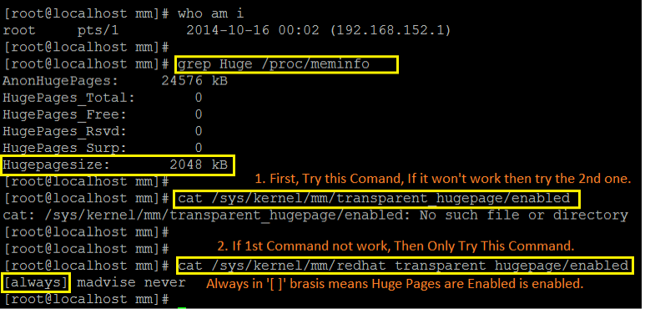

2. Steps to Disable the **Transparent Huge page**

Add the configuration **transparent_hugepage=never** to the Config file **/etc/grub.conf.**

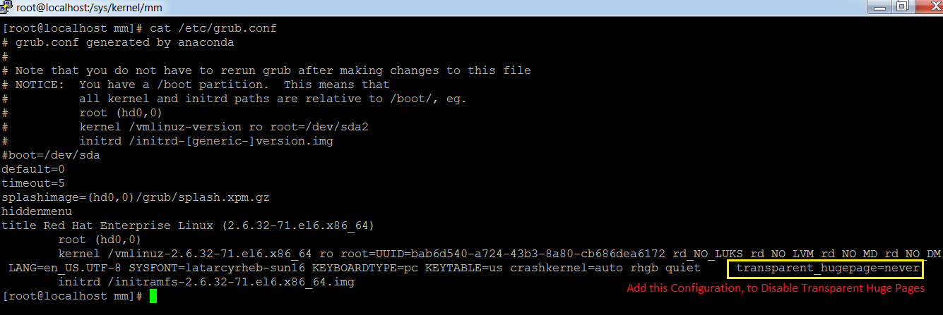

3. Restart the Server.

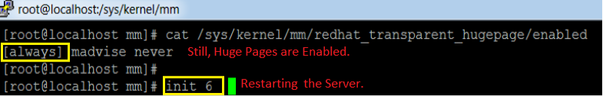

4. check the **Transparent Huge page** Status Again.

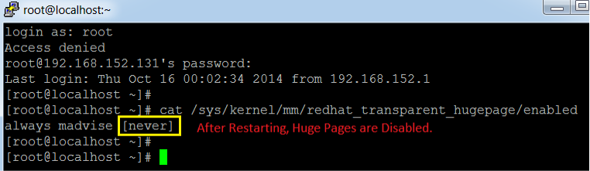

B. Enabling Replica Set Means Maintaining Duplicate Set of Data, So this Redundant Data Can be Useful I the Case of Data Lost.

1. Primary Instance: Actual Instance Which Has the Original Database

2. Secondary Instance: Duplicate Set of Primary Data

3. Arbiter Instance: Do not Have Any Data Set.

All CURD Operations Will Apply to Primary Node.

If Secondary Instance is Enabled with **Slave-Ok** Feature**,** Then Only Read Operation is Allowed From Secondary Instance.

C. To Start the tokumx with Replica Set, tokumx Should have the Following Configuration.

1. One Primary tokumx Instances

2. One Secondary tokumx Instance

3. One Arbiter tokumx Instance

To Handle the Fail-Over, Replica Set should have Magical Number of Replica Set Instances.

Now See How the Magical Number, 3 Works for with tokumx instances,Since, tokumx uses Special Algorithm to Select the Primary Replica Instance. Each Instance will Get 1 vote, except Arbiter.

Now, the Arbiter Will Vote any One replica Instance only So that the same replica Instance become Primary.

If In the Case of Primary Instance is down, Arbiter Will Vote the Other replica Instance so that the Secondary will become Primary This Time. Now, If We Start the Stopped Instance, Now it will Become Secondary.

Arbiter Instance is Always Arbiter Only. It wo't Become Primary or Secondary at Any Time.

D. To Enable Authentication, We Should Have Users.

In tokumx, For each User, again we have Some Limited Set Of Roles.[we can define User Defined Roles also] acting on the Users.

Every Secured tokumx must has

1. user-admin user[Creating, Editing and removing all Users including root user ]

2. root user [Data Base Admin]

3. normal users [Schema Level User]

**Installation Guide for Tokumx**

**Step 1.** copy the **tokumx-1.5.0-linux-x86_64-main.tar.gz** file to the Given path

path: **/home/appuser/tokuMX**

**Step 2.** Unzip the .gz file with the command

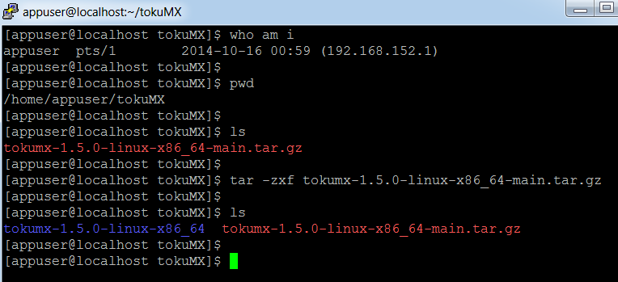

**tar -zxvf tokumx-1.5.0-linux-x86_64-main.tar.gz>**

Step 3: Create the user called mongo by the below command

**$useradd mongo**

**$passwd mongo**

Step 4 : As root User Create the directory for the Database Path

$cd /

$mkdir

$cd /snoc

$mkdir mongo

$cd /snoc/mongo

$mkdir /tokumx-data

$chown -R mongo:mongo /snoc/mongo

Step 5 : Login As Mongo User And follow the steps below.

su - mongo

**Step 6.** Add the **tokumx-data** directory in the **/ṣnoc/mongo/tokumx-data/** Directory.

And add the three More Directories in ' tokumx-data'.

They are

1. r01

2. r02

3. r03

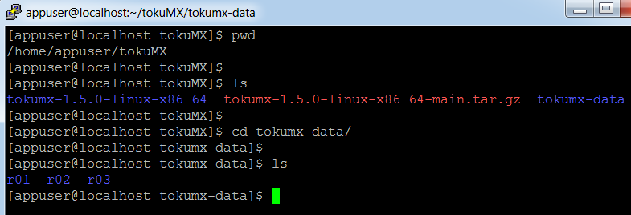

**Step 4.** Add **conf** folder in the **/etc/mongoconf/** directory

$cd /etc

$mkdir mongocof

$cd mongoconf

$cd conf

**Step 5.** In **conf** folder add **r01.config** file with following Configuration.

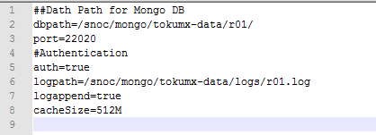

##Dath Path for Mongo DB

dbpath=/snoc/mongo/tokumx-data/r01/

port=22020

#Authentication

auth=true

logpath=/snoc/mongo/tokumx-data/logs/r01.log

logappend=true

cacheSize=512M

**Step 6 :** Start the tokumx Instance using the below Command:

**mongod --config=/etc/mongoconf/r01.config &**

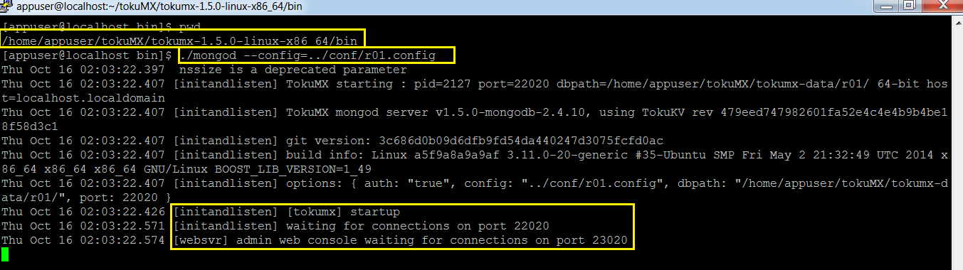

**Step 7**: Start the mongo Shell for the above Instance

command: **mongo --port 22020**

**Step 8:** In mongo shell run the following command for Create **User Admin**

command:

* **use admin**
* **db.addUser({"user":"user","pwd":"user","roles":["userAdminAnyDatabase"]})**

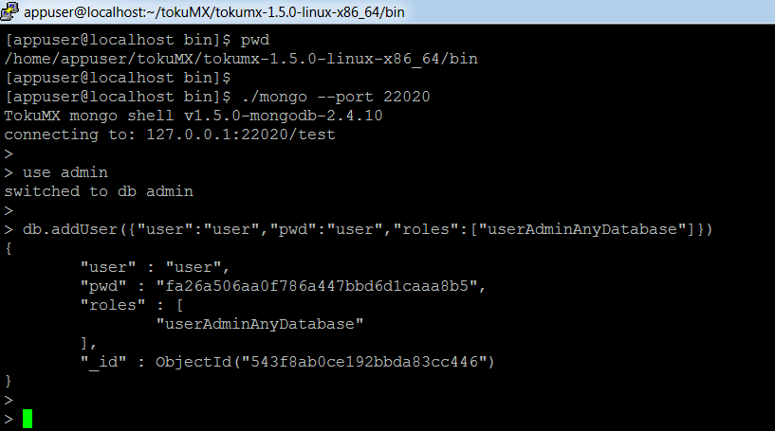

Step 9: Create **admin** user with '**user**' user, who is just now created, using the follwing Command:

Comand:

* **use admin**
* **db.auth('user','user')**

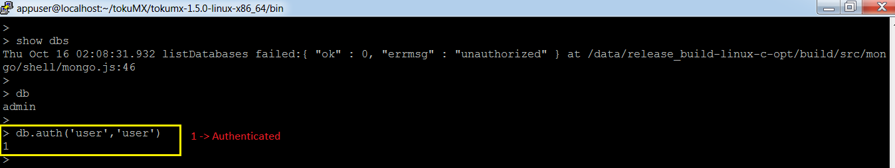

* **use admin**
* **db.addUser({"user":"admin","pwd":"admin","roles":["clusterAdmin","readWriteAnyDatabase", "dbAdminAnyDatabase", "userAdminAnyDatabase"]})**

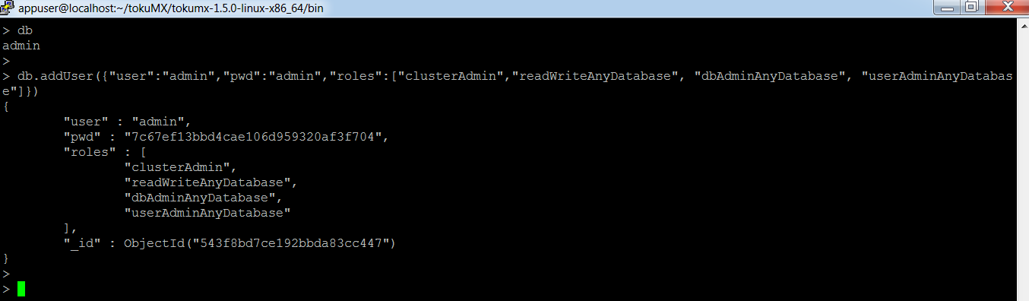

**Step 11:** Stop the tokumx Instances

Stop the mongo Shell which we started in Step 7.

* exit

Stop the tokumx Instance which we started in Step 6.

Command : **mongod –config=/etc/mongoconf/r01.config --shutdown**

step 12: Create **keyfile-store** folder in the path **/etc/mongoconf**

step 13: Create **mongodb-keyfile** in the folder: **keyfile-store** using below command

command: **openssl rand –base64 741 > mongodb-keyfile**

Change the Permission for this **mongodb-keyfile** to **600** using the following Command:

Commond: **chmod 600 mongodb-keyfile**

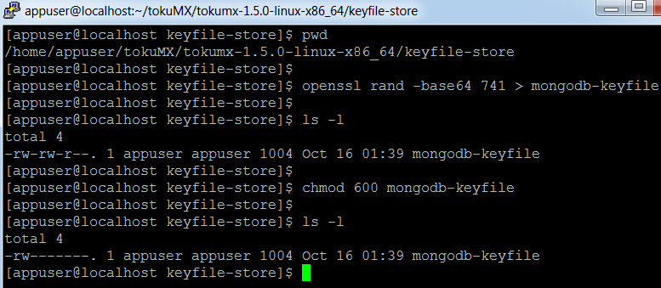

Step 14: Change the Configuration file, **r01.config,** as Given Below.

Step 15: Create the Configuration file, **r02.config**, as Given Below.

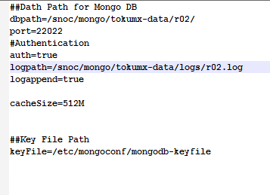

Step 16: Create the Configuration file, **r03.config**, as Given Below.

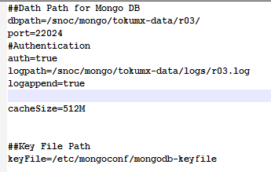

**Step 17:** Start the Three tokumx Instances As given Below

**Step 17.1:** Start the Fisrt tokumx Instance.

Comand:

run the Command: **mongod --config=/etc/mongoconf/r01.config &**

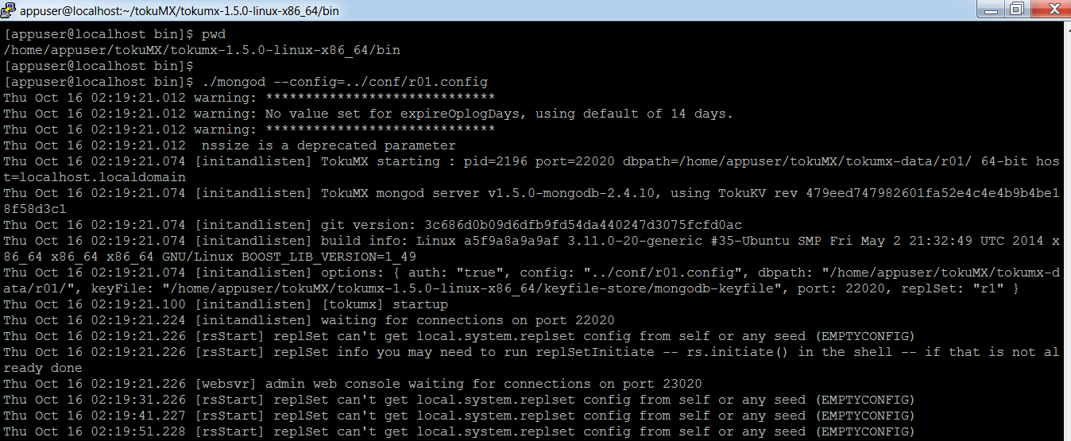

**Step 17.2:** Start the Second tokumx Instance.

Comand:

run the Command:  **mongod –config=/etc/mongoconf/r02.config &**

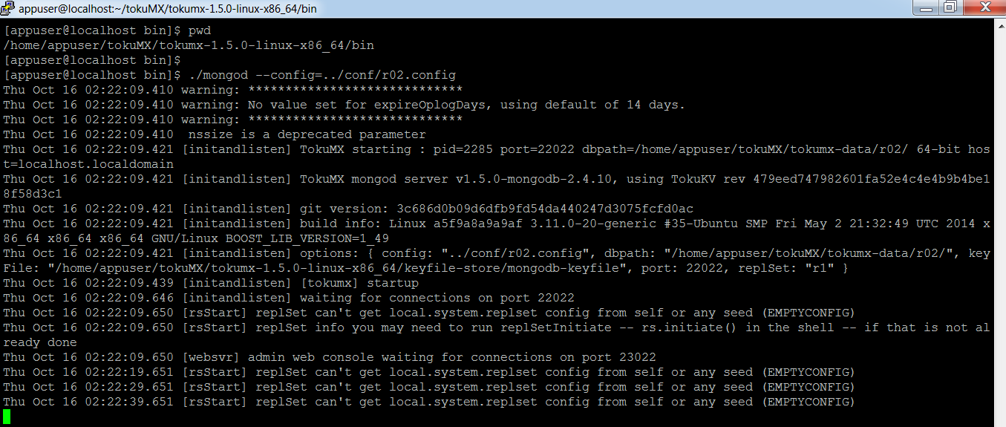

**Step 17.3:** Start the Third tokumx Instance.

Comand:

run the Command:  **mongod –config=/etc/mongoconf//r03.config &**

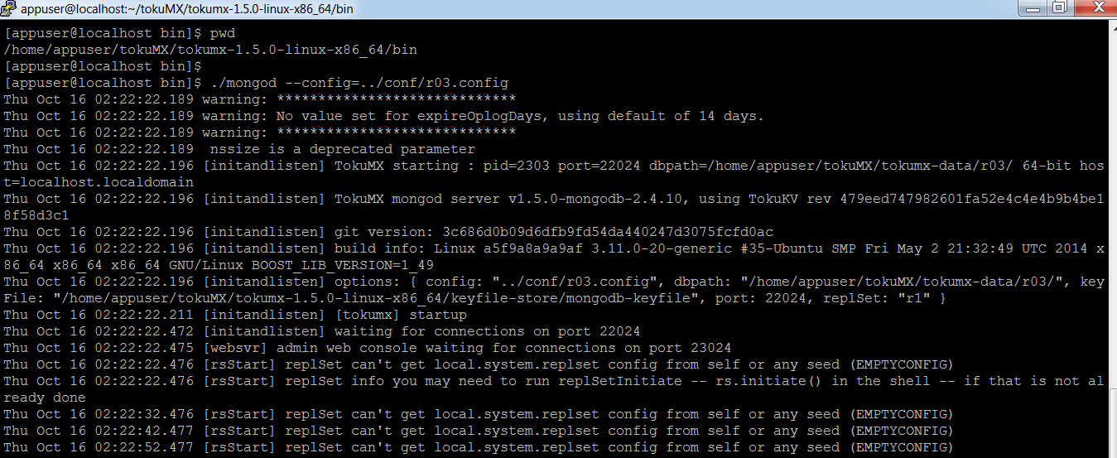

**Step 18**: Start the mongo Shell for the First Instance

**mongo –port 22020**

Step 19: use **admin** user to authenticate.

Command:

* **Use admin**
* **db.auth('admin','admin')**

Step 20: Initiate the Replica Set with the Following Command:

command:

* **rs.initiate({"_id":"r1","members":[{"_id":0,"host":"mongo1.snocprod.com:22020"},{"_id":1,"host":"mongo2.snocprod.com:22022"},{"_id":2,"host":"mongo3.snocprod.com:22024","arbiterOnly":true}]})**

**And edit the /etc/hosts file by adding the domain names to the respective IP.**

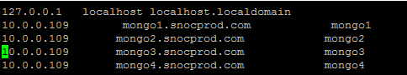

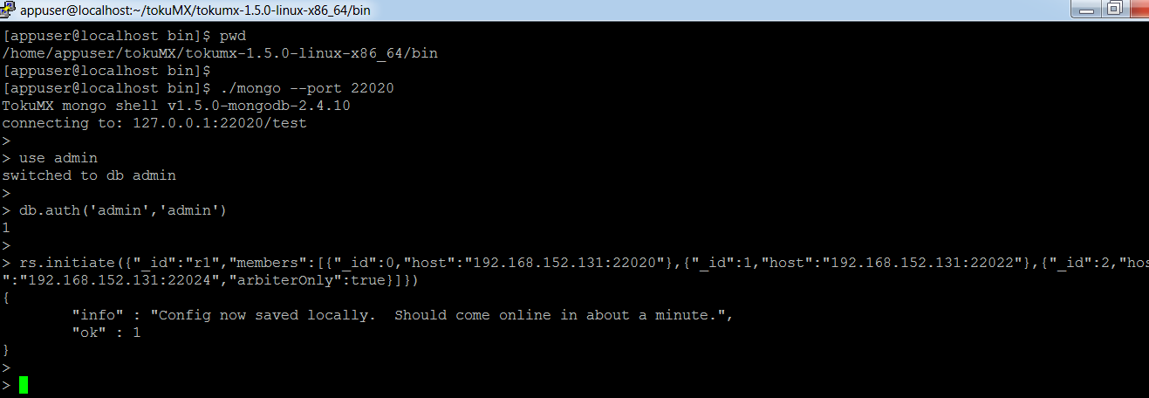

Step 21: Check the Logs of the All Servers:

for Primary tokumx Instance:

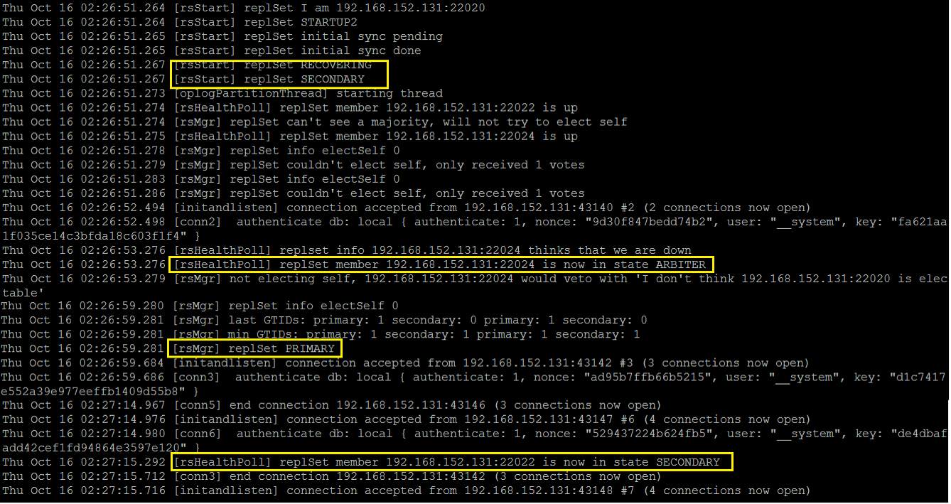

for Secondary tokumx Instance:

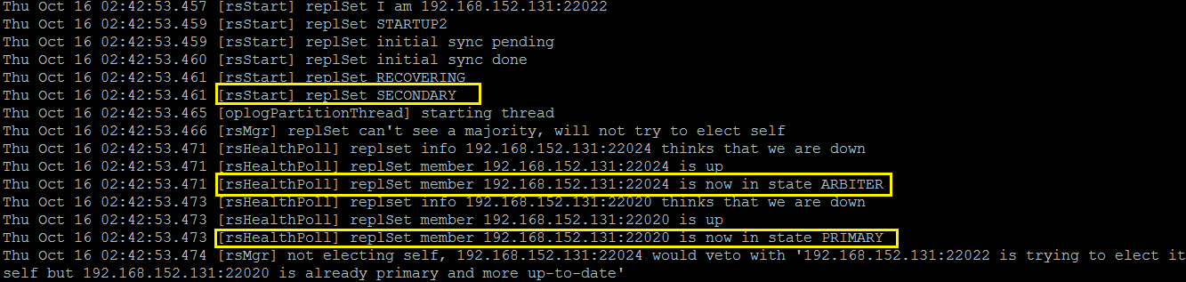

for Arbitary Instance:

